**SCS2208 Rapid Application Development**

**Group Assignment 01**



**Group Members**

1. 21000395 – A. D. N. De Zoysa
2. 21000557 – D. G. D. Dissanayake
3. 21001022 – S. M. Kularathne
4. 21001032 – M. J. S. Kulathilaka

**GitHub Repo:** https://github.com/janindu-kulathilaka/RAD-Group-Project

**Google Drive link (Video):**

**Functionalities**

**Customer**

1. 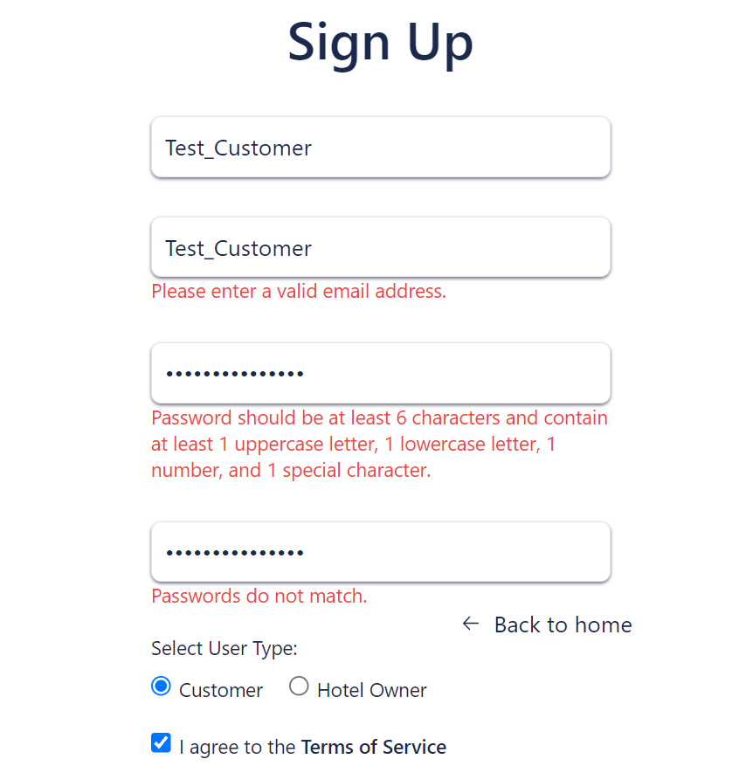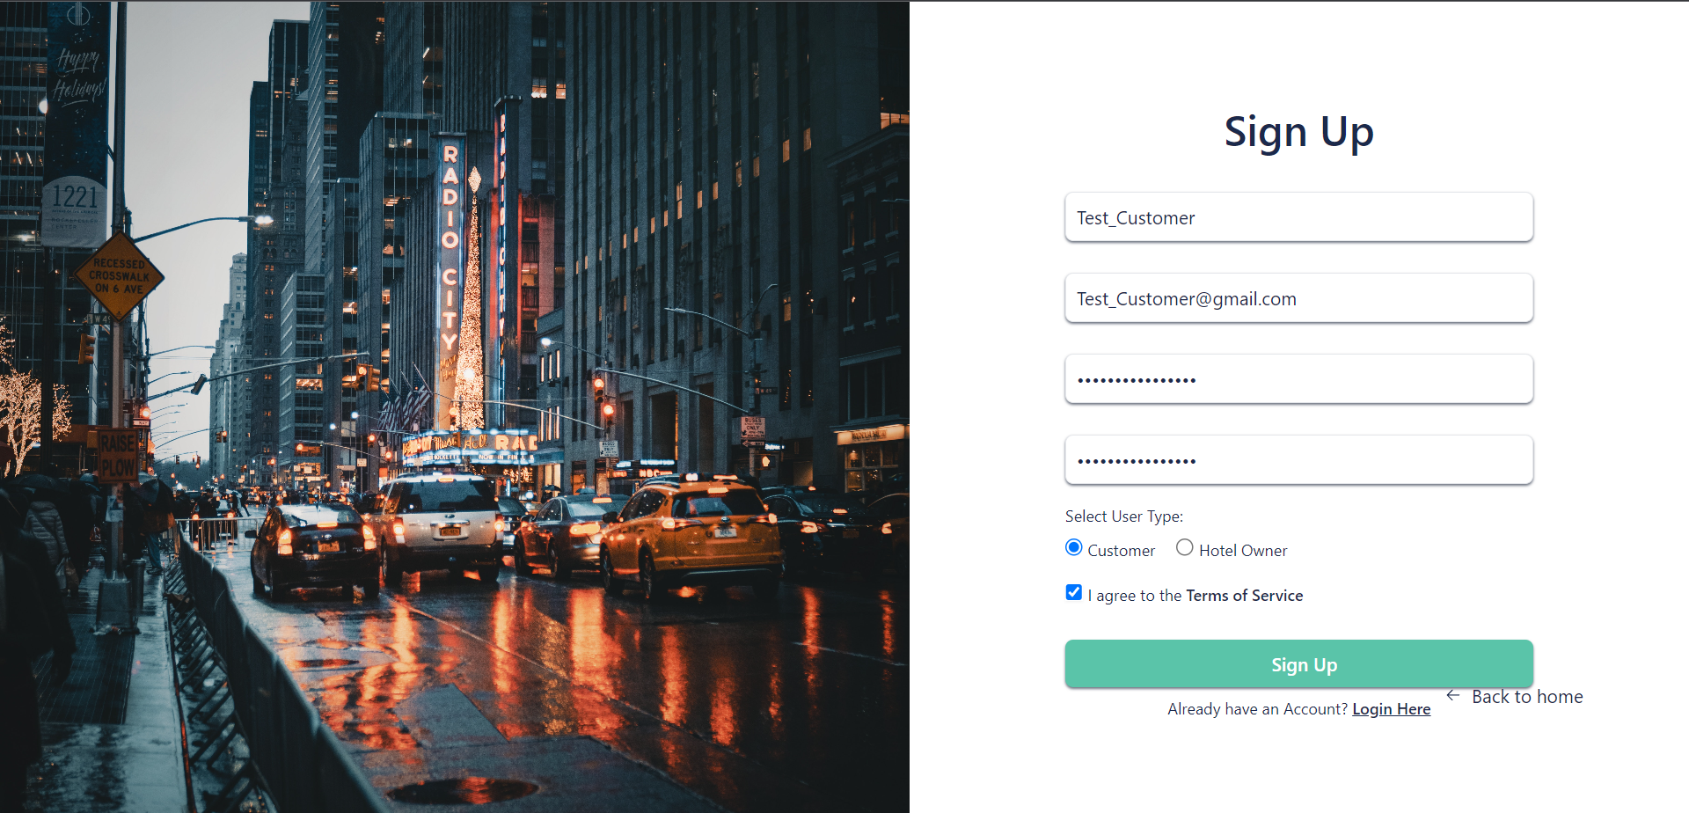Register as Customer  
     
     
     
     
     
   ***Validate user data***

* *The system check if the email is in the valid format*
* 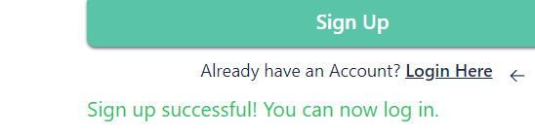*There are minimum requirements for a password(strength check)*  
    
    
    
    
    
    
    
    
   *Confirmations*

1. 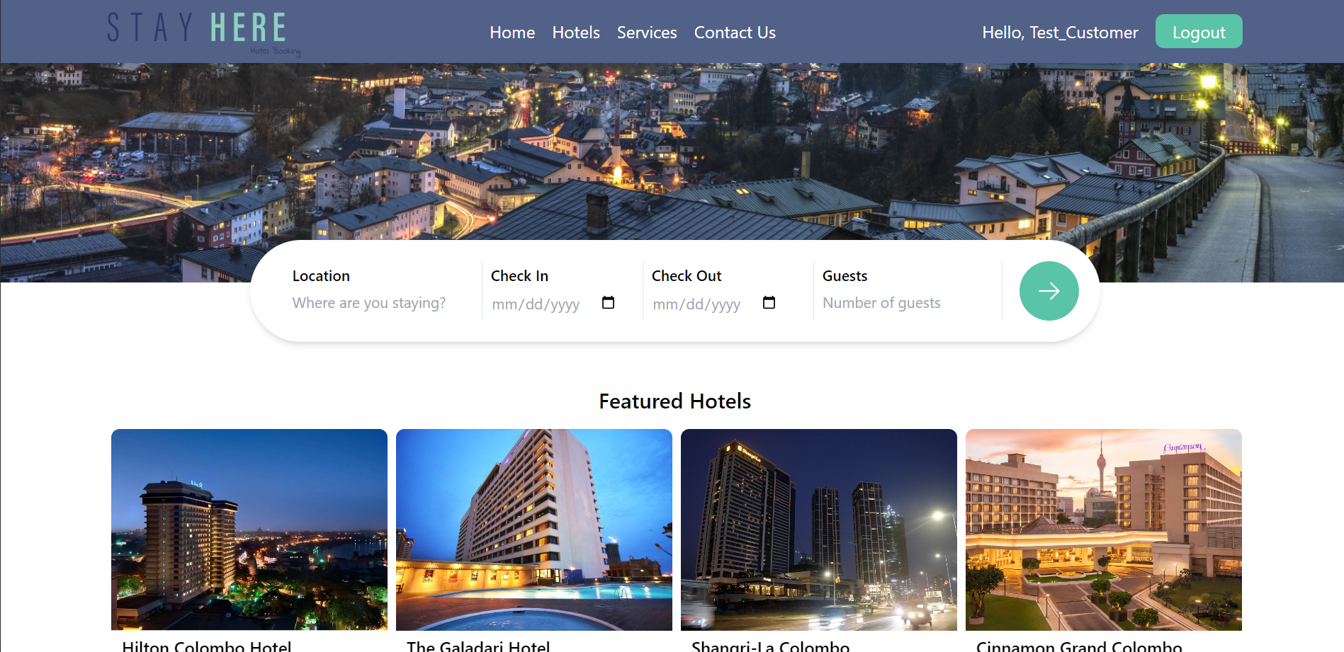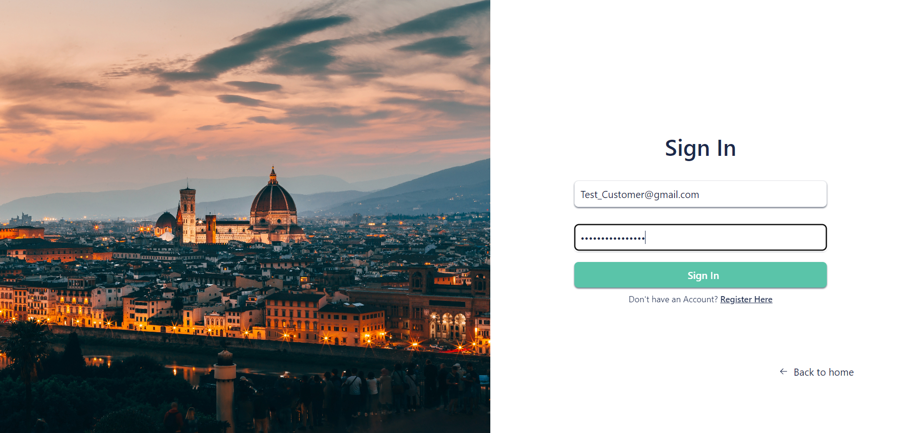Login
2. 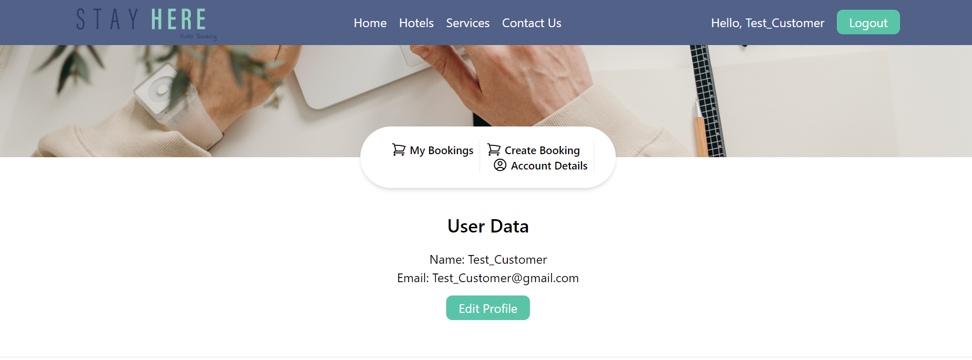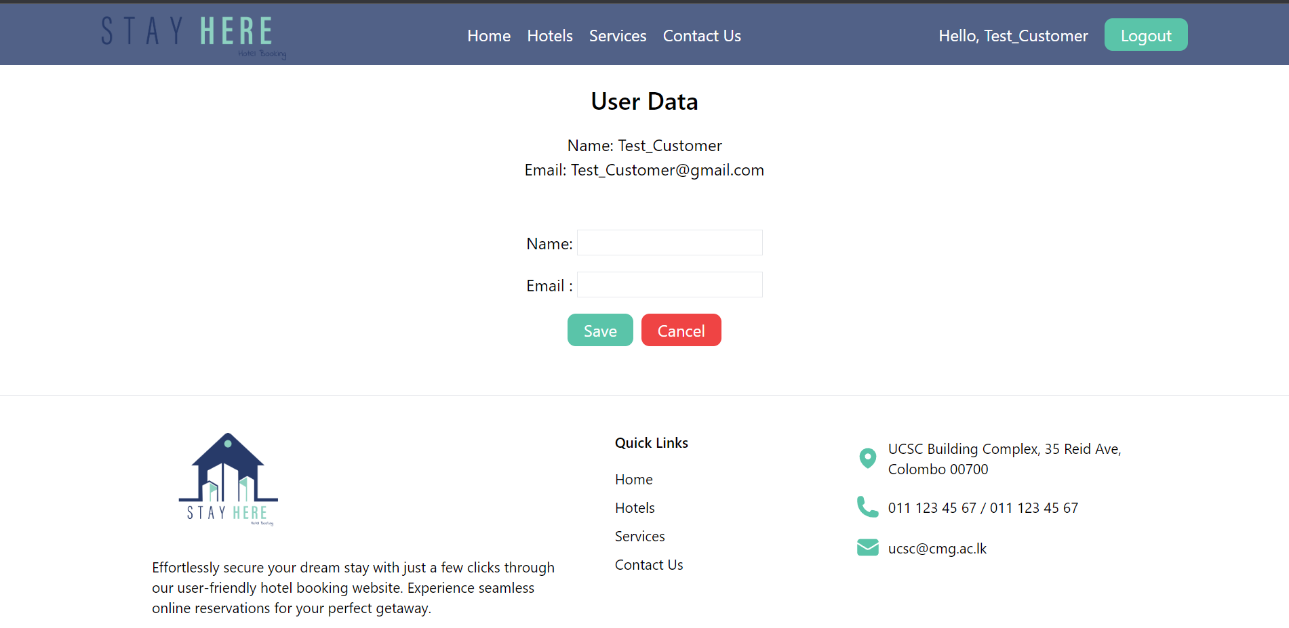 Edit user data  
     
     
   *Users can change their name and e-mail addresses.*
3. 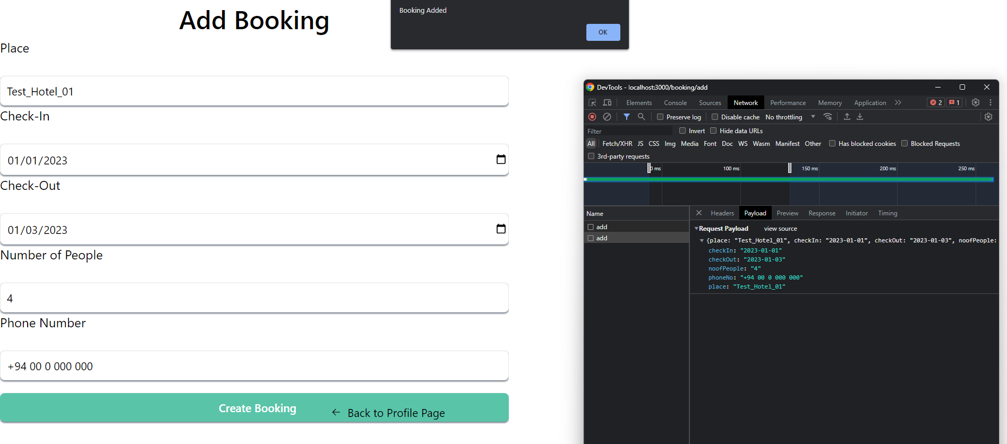Create a booking
4. View bookings
5. Delete bookings  
     
     
     
     
     
     
     
     
     
     
     
     
     
     
     
     
     
     
     
     
     
   **Hotel Owner**
6. 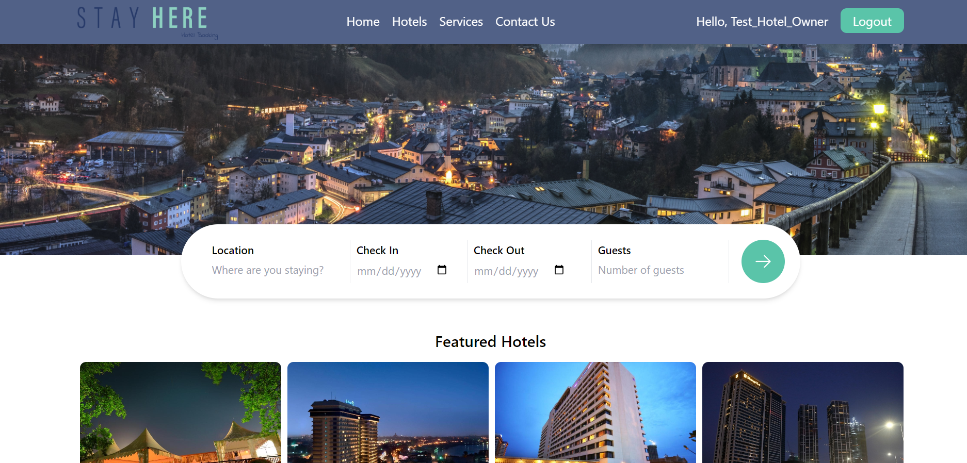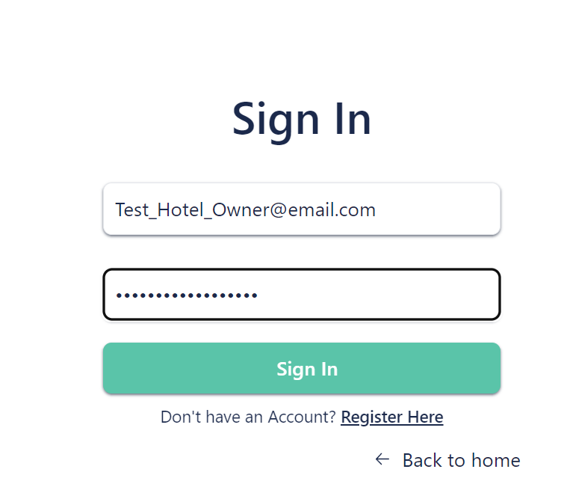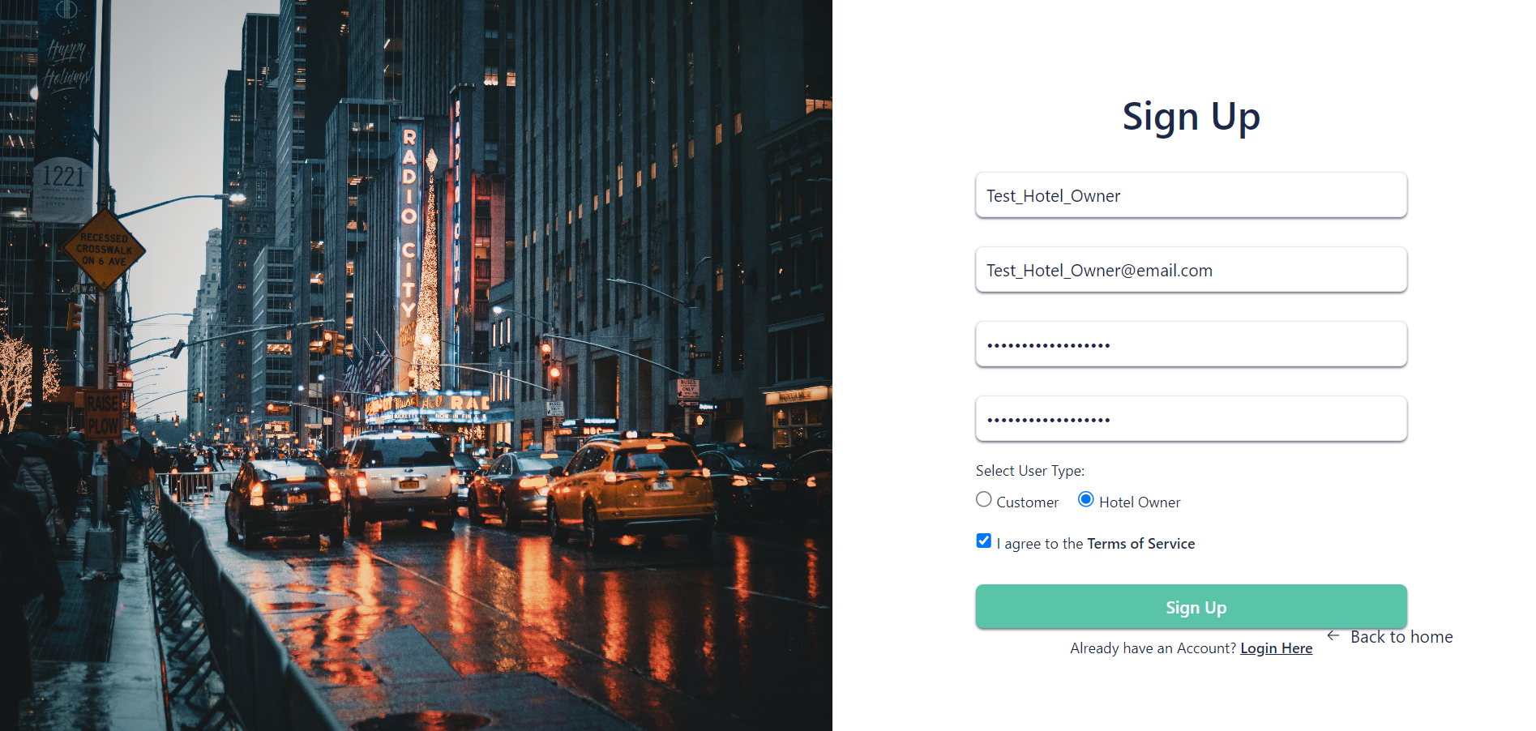Register/ Login